Project Design Phase
Problem – Solution Fit Template

Date | 01 Nov 2025
Team ID | NM2025TMID01600
Project Name | Laptop Request Catalog Item
Maximum Marks | 2 Marks

Problem – Solution Fit Template:
The Problem–Solution Fit ensures that the solution directly addresses a real organizational need. In this project, the challenge was the manual and inefficient laptop request process, which caused delays, missing data, and lack of tracking. The solution developed — a Laptop Request Catalog Item in ServiceNow — automates and streamlines the request process, ensuring data accuracy, faster approval, and improved user experience.
Purpose:
❑ Simplify and automate the laptop request process for employees.

❑ Ensure accurate data capture through form validations and dynamic UI policies.

❑ Reduce manual effort and improve processing time for IT support teams.

❑ Enhance transparency and traceability of all laptop requests via update sets.

❑ Provide an intuitive user interface for easy form submission and modification.

Template:
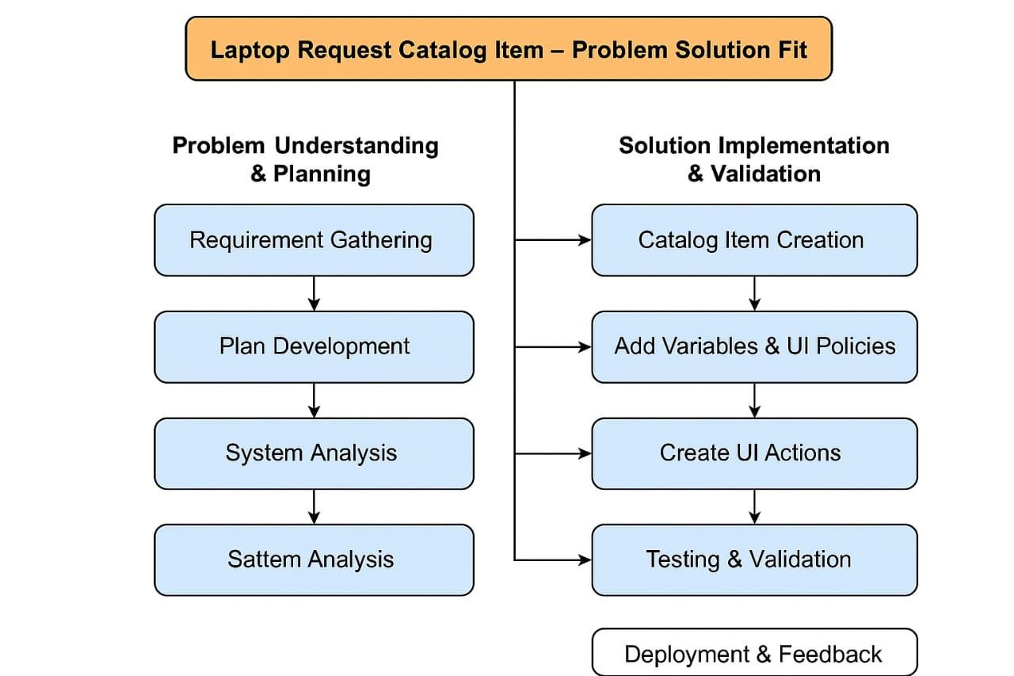

The project “Laptop Request Catalog Item” effectively modernizes the manual laptop requisition process within an organization by leveraging ServiceNow’s Service Catalog module. Through automation, validation rules, and UI enhancements, it ensures faster processing, fewer human errors, and better data governance. The successful implementation demonstrates how IT Service Management tools can improve workflow efficiency, user satisfaction, and operational transparency across enterprise environments.

